**Part-of-speech (POS) tagging**

**Part-of-speech (POS)** tagging is a fundamental task in natural language processing (NLP) that involves assigning a grammatical category (such as noun, verb, adjective, etc.) to each word in a given text. The tags indicate the syntactic role and function of a word within a sentence. This information is crucial for various NLP applications, including machine translation, information retrieval, sentiment analysis, and more.

**Example:**

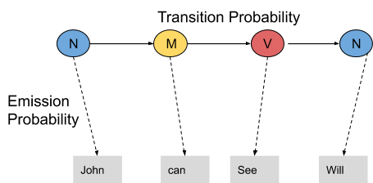

In this example, we consider only 3 POS tags that are noun, model and verb. Let the sentence “ Ted will spot Will ” be tagged as noun, model, verb and a noun and to calculate the probability associated with this particular sequence of tags we require their Transition probability and Emission probability.

**Part-of-speech (POS)** tagging is a fundamental task in natural language processing (NLP) that involves assigning a grammatical category (such as noun, verb, adjective, etc.) to each word in a given text. The tags indicate the syntactic role and function of a word within a sentence. This information is crucial for various NLP applications, including machine translation, information retrieval, sentiment analysis, and more.

For instance, in the sentence "The quick brown fox jumps over the lazy dog," a POS tagger would identify each word's part of speech:

* "The" -> determiner
* "quick" -> adjective
* "brown" -> adjective
* "fox" -> noun
* "jumps" -> verb
* "over" -> preposition
* "the" -> determiner
* "lazy" -> adjective
* "dog" -> noun

There are several approaches to POS tagging, including:

1. **Rule-Based Tagging:** This approach uses predefined rules and patterns to assign POS tags based on features like capitalization, suffixes, and context.
2. **Statistical Tagging:** This method uses statistical models (like Hidden Markov Models or Maximum Entropy Models) trained on large corpora to predict the most likely tag for a given word based on its context.
3. **Machine Learning Tagging:** This approach employs machine learning algorithms, often based on neural networks, to learn the mapping between words and their respective POS tags from annotated training data.
4. **Deep Learning Tagging:** This involves using deep learning architectures, such as recurrent neural networks (RNNs) or transformer-based models (like GPT-3), to perform POS tagging. These models are capable of capturing complex contextual information.

State-of-the-art models like BERT and GPT-3, although primarily designed for tasks like language modeling and understanding, are also capable of performing POS tagging as a side effect of their training on massive amounts of text data.

POS tagging is a crucial preprocessing step for many NLP applications as it provides important linguistic information about a text that can be leveraged for more sophisticated tasks.

==============================================================

Hidden Markov Model (HMM)

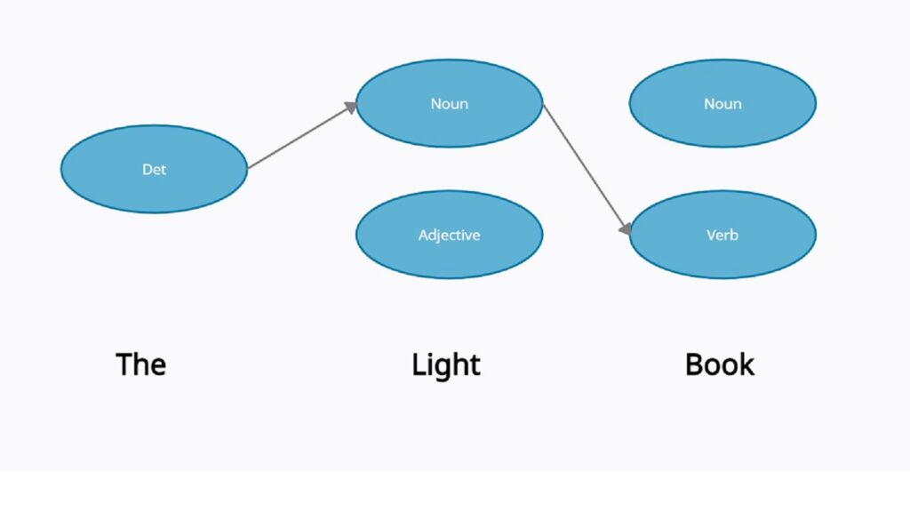

Hidden Markov Model (HMM) tagging is a method for part-of-speech (POS) tagging in natural language processing (NLP). It's based on the probabilistic modeling of sequences of words, assuming that each word in a sequence is generated by a hidden state in a Markov chain.

Here's a basic outline of how HMM tagging works:

1. **States:** In HMM tagging, the states represent the different POS tags (e.g., noun, verb, adjective, etc.).
2. **Observations:** The observations are the actual words in the text.
3. **Transition Probabilities:** These represent the probability of transitioning from one state (POS tag) to another. For example, the probability of transitioning from a noun to a verb.
4. **Emission Probabilities:** These represent the probability of a particular word being emitted from a particular state. For example, the probability of the word "jump" being emitted from the verb state.
5. **Initialization Probabilities:** These represent the probability of starting in a particular state.

The goal of HMM tagging is to find the most likely sequence of POS tags given an observed sequence of words. This is done using the Viterbi algorithm, which efficiently computes the most probable sequence of states.

For example, consider the sentence "The quick brown fox jumps over the lazy dog." In HMM tagging, you'd compute the sequence of POS tags (e.g., determiner, adjective, noun, verb, etc.) that maximizes the joint probability of the observed words and their corresponding tags.

HMM tagging has been widely used in NLP and was historically one of the most effective methods for POS tagging. However, more recent approaches, such as neural network-based models (like recurrent neural networks and transformers), have surpassed HMMs in terms of performance, especially on complex tasks and large datasets.

Nonetheless, HMM tagging remains a valuable tool in cases where simplicity, transparency, and computational efficiency are important considerations.

==================================================================

Named Entity Recognition (NER)

Named Entity Recognition (NER) is a natural language processing (NLP) task that involves identifying and classifying named entities in text into predefined categories. Named entities are typically real-world objects such as people, organizations, locations, dates, percentages, and more. NER is an essential component of various NLP applications, including information extraction, question answering, text summarization, and sentiment analysis.

Example: (Source https://www.shaip.com/blog/named-entity-recognition-and-its-types/)

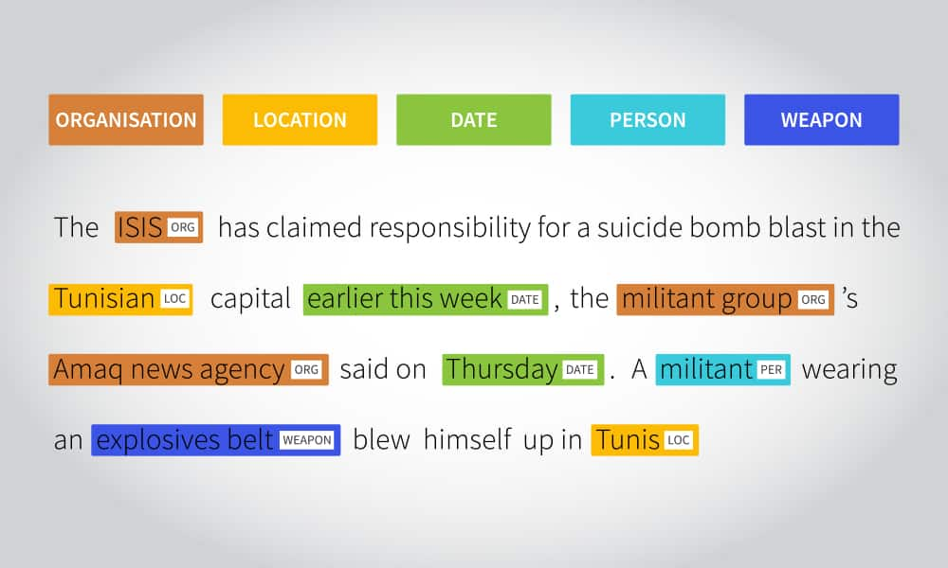

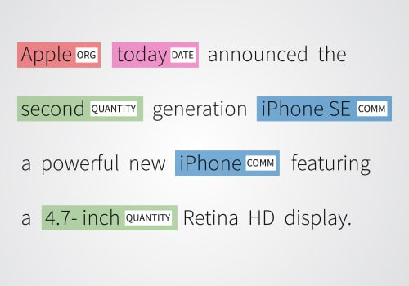

The main goal of NER is to extract structured information from unstructured text by locating and categorizing named entities. Common categories for named entities include:

1. **Person**: Identifying names of individuals, like "John Smith" or "Barack Obama."
2. **Organization**: Recognizing the names of companies, institutions, or agencies, such as "Google" or "NASA."
3. **Location**: Identifying places and geographic locations, such as "New York City" or "Mount Everest."
4. **Date**: Recognizing various forms of dates, like "January 1, 2020" or "2023-10-14."
5. **Time**: Identifying specific times or time ranges, such as "3:30 PM" or "during the summer."
6. **Percentages**: Recognizing percentages, like "30%" or "two-thirds."
7. **Money**: Identifying currency amounts, such as "$100" or "€50."
8. **Quantity**: Recognizing numerical quantities, like "5 million" or "three cups."
9. **Product**: Categorizing product names, for example, "iPhone" or "Coca-Cola."
10. **Event**: Identifying event names, such as "World Cup" or "Olympic Games."

NER models use various techniques, including rule-based systems, machine learning, and deep learning approaches like recurrent neural networks (RNNs) and transformer-based models (e.g., BERT, GPT-3). These models are trained on labeled data that provides examples of text with annotated named entities and their corresponding categories. Once trained, NER models can be used to automatically extract structured information from unstructured text, making it easier to process and analyze large volumes of textual data.

==========================================================

**Evaluation of Named Entity Recognition**

The evaluation of Named Entity Recognition (NER) involves assessing the performance of a NER system or model in identifying and categorizing named entities correctly in a given text. There are several standard metrics and methods used to evaluate NER systems:

1. **Precision, Recall, and F1-Score**:
   * **Precision**: It is the ratio of true positive predictions to the total number of predicted entities. It measures the accuracy of the model's predictions. Mathematically, it is defined as TP / (TP + FP).
   * **Recall**: It is the ratio of true positive predictions to the total number of actual entities in the dataset. It measures the ability of the model to capture all the relevant entities. Mathematically, it is defined as TP / (TP + FN).
   * **F1-Score**: It is the harmonic mean of precision and recall. It provides a balance between precision and recall and is often used as a single metric to assess the overall performance of the model. Mathematically, it is defined as 2 * (Precision * Recall) / (Precision + Recall).
2. **Accuracy**:
   * Overall accuracy is the ratio of correctly identified entities (both true positives and true negatives) to the total number of entities. While accuracy is important, it may not be the most informative metric for imbalanced datasets, where one category may dominate.
3. **Confusion Matrix**:
   * A confusion matrix provides a detailed breakdown of the model's performance by showing the number of true positives, true negatives, false positives, and false negatives.
4. **Entity-Level Evaluation**:
   * This involves comparing the predicted entities with the actual entities in the text. This can be useful for understanding which specific entities are being correctly or incorrectly identified.
5. **Token-Level Evaluation**:
   * In this evaluation, each token in the text is considered separately. The model's prediction for each token is compared to the actual entity label. This can reveal more granular insights into the model's performance.
6. **Cross-Validation**:
   * Divide the dataset into multiple folds, train and evaluate the model on each fold, and then average the performance metrics. This helps in assessing the model's generalization ability.
7. **Out-of-Domain Testing**:
   * Evaluating the model on data from a domain or context that it has not been trained on. This helps to determine if the model can perform well in real-world scenarios.
8. **Baseline Comparisons**:
   * Compare the performance of the NER model with a simple baseline, such as a rule-based system or a basic heuristic, to provide context for the model's effectiveness.
9. **Error Analysis**:
   * Investigate specific cases where the model performs poorly. Understanding the types of mistakes it makes can provide insights into areas for improvement.

It's important to note that the choice of evaluation metrics should be based on the specific requirements and goals of the NER application. Additionally, a diverse and representative dataset is crucial for meaningful evaluation.

===================================================================

Syntax and parsing

Syntax and parsing are two fundamental concepts in natural language processing (NLP) that are closely related:

1. **Syntax**:
   * **Definition**: Syntax refers to the rules and principles that govern the structure of sentences in a language. It deals with how words combine to form phrases, clauses, and sentences, and how those structures convey meaning.
   * **Components of Syntax**:
     + **Phrases**: Groups of words that function as a single unit in a sentence (e.g., noun phrases, verb phrases).
     + **Constituents**: Units of syntax, such as words or phrases, that form larger structures.
     + **Sentence Structure**: The hierarchical arrangement of phrases and constituents in a sentence.
     + **Grammar Rules**: Rules that dictate how different types of phrases can be formed and combined.
   * **Example**:
     + In the sentence "The cat chased the mouse," we have a noun phrase ("The cat") and a verb phrase ("chased the mouse") that combine to form a complete sentence.
2. **Parsing**:
   * **Definition**: Parsing is the process of analyzing the grammatical structure of a sentence to determine its syntactic components and their relationships. It involves breaking down a sentence into its constituent parts according to a specific grammar.
   * **Types of Parsing**:
     + **Constituency Parsing**: In this type of parsing, the goal is to identify the constituents (phrases) in a sentence and their hierarchical relationships. It produces a tree structure known as a parse tree.
     + **Dependency Parsing**: Here, the focus is on identifying the dependencies between words in a sentence. It produces a directed graph known as a dependency tree.
   * **Parsing Techniques**:
     + Various parsing techniques, such as top-down, bottom-up, transition-based, and graph-based parsing, are used to perform the syntactic analysis of sentences.
   * **Example**:
     + For the sentence "The quick brown fox jumps over the lazy dog," a constituency parser would generate a parse tree that shows how the sentence is structured into noun phrases, verb phrases, etc.
   * **Applications**:
     + Parsing is used in a wide range of NLP tasks, including machine translation, information extraction, sentiment analysis, and more. It is a critical step in understanding the meaning of text.
   * **Challenges**:
     + Parsing can be challenging due to issues like structural ambiguity (where a sentence can have multiple valid parse trees) and the need for efficient algorithms to handle large-scale parsing tasks.

In summary, syntax provides the rules for constructing sentences, and parsing is the process of applying those rules to understand the structure of a given sentence. Together, they form the basis for many advanced NLP applications.

==================================================================================

**Parsing techniques**

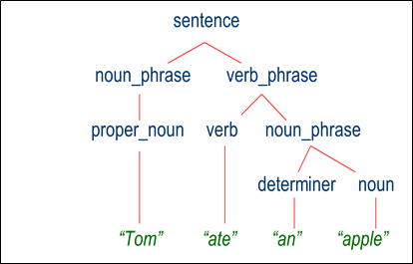

Parsing techniques refer to the methods and algorithms used in natural language processing (NLP) to analyze and understand the grammatical structure of sentences. These techniques are crucial for tasks like syntactic and semantic analysis, information extraction, and machine translation. Here are some of the commonly used parsing techniques

=======================================================

Dependency parsing

Dependency parsing is a technique in natural language processing (NLP) used to analyze the grammatical structure of a sentence. It focuses on establishing syntactic relationships (dependencies) between words in a sentence. In a dependency parse tree, each word in the sentence is represented as a node, and the relationships between words are represented as directed edges.

Key points about dependency parsing include:

1. **Directed Acyclic Graph (DAG)**: Dependency parse trees are directed acyclic graphs because they must not contain cycles. This means that if you start from any word and follow the edges, you will eventually reach a terminal node without revisiting any previous nodes.
2. **Dependency Labels**: The edges in a dependency parse tree are labeled with grammatical relations. These labels indicate the type of syntactic relationship between the words. For example, labels might indicate subject, object, modifier, etc.
3. **Root Node**: There is always one node in the parse tree that has no incoming edges. This is called the root node and represents the main verb or main predicate of the sentence.
4. **Projectivity**: A dependency tree is said to be projective if, for every pair of words A and B in the sentence, all words that lie between A and B in the linear order also have a path connecting them to the root. Non-projective trees allow for crossing arcs.
5. **Dependency Parsing Algorithms**:
   * **Transition-Based Parsing**: This is a greedy parsing method where the parser moves through a sequence of actions to construct the parse tree. Actions include shifting a word onto the stack, reducing a set of words into a phrase, etc.
   * **Graph-Based Parsing**: This approach treats dependency parsing as a global optimization problem. It scores entire trees and finds the highest-scoring tree for a given sentence.
6. **Applications**:
   * Dependency parsing is used in various NLP tasks such as information extraction, question answering, machine translation, sentiment analysis, and more.
7. **Multilingual Parsing**: Dependency parsing is particularly effective for languages with relatively free word order, and it has been applied to a wide range of languages, making it a versatile parsing technique.
8. **Dependency Parsing Models**:
   * **Transition-Based Models**: These models use neural networks to predict the next action in the parsing process (e.g., shift, reduce).
   * **Graph-Based Models**: These models use neural networks to score potential arcs between words and use algorithms to find the best tree.
9. **Evaluation**:
   * Dependency parsers are evaluated using metrics like Unlabeled Attachment Score (UAS) and Labeled Attachment Score (LAS), which measure how many dependencies are correctly predicted.

Dependency parsing is a crucial component in many NLP applications, and accurate dependency parsing is essential for tasks that require a deep understanding of sentence structure. It has found applications in tasks like machine translation, sentiment analysis, information extraction, and more.

Constituency parsing,

Constituency parsing, also known as phrase structure parsing, is a natural language processing technique used to analyze the grammatical structure of a sentence. It involves breaking down a sentence into its constituent parts, such as noun phrases (NP), verb phrases (VP), prepositional phrases (PP), etc., according to a specified grammar.

Here are some key points about constituency parsing:

1. **Phrase Structure Grammar**: Constituency parsing is based on the idea of phrase structure grammar, which describes how sentences can be recursively divided into constituents (phrases).
2. **Context-Free Grammar (CFG)**: Constituency parsing often employs context-free grammars, which define the rules for combining words into phrases and sentences. A CFG consists of a set of production rules that specify how different constituents can be combined.
3. **Parse Trees**: The output of a constituency parser is a parse tree. In this tree, each node represents a constituent, and the edges represent the grammatical relationships between constituents.
4. **Non-Terminals and Terminals**: Non-terminal nodes in the parse tree represent phrases, while terminal nodes represent individual words in the sentence.
5. **Root Node**: The topmost node in the parse tree is the root node, which represents the entire sentence.
6. **Phrase Labels**: Each node in the parse tree is labeled with a phrase category (e.g., NP for noun phrase, VP for verb phrase). These labels indicate the type of constituent represented by the node.
7. **Ambiguity**: Constituency parsing can face challenges due to structural ambiguity in natural language. For example, a sentence may have multiple valid parse trees representing different syntactic interpretations.
8. **Parsing Algorithms**:
   * **Top-Down Parsing (e.g., Recursive Descent)**: These algorithms start with the root node and recursively apply production rules to expand non-terminal symbols until terminal symbols (words) are reached.
   * **Bottom-Up Parsing (e.g., CYK Algorithm)**: These algorithms start with the words and combine them into larger constituents according to the grammar rules.
9. **Probabilistic Context-Free Grammar (PCFG)**: This is an extension of context-free grammar where each production rule is associated with a probability. It is often used in statistical parsing to assign probabilities to different parse trees.
10. **Applications**:
    * Constituency parsing is used in a variety of natural language processing tasks such as machine translation, information extraction, sentiment analysis, and more.
11. **Evaluation**:
    * Common metrics for evaluating constituency parsers include Precision, Recall, and F1-score, which measure how well the predicted constituents match the gold-standard constituents.

Constituency parsing is an important step in understanding the syntactic structure of a sentence. It provides a foundation for more advanced natural language processing tasks and is widely used in applications where a deep understanding of language syntax is required.

Maximum Entropy Markov Models

Maximum Entropy Markov Models (MEMMs) are a type of probabilistic model used in natural language processing and other sequential labeling tasks. They are an extension of Hidden Markov Models (HMMs) that incorporate features from the input data directly into the model.

Here are some key points about MEMMs:

1. **Markov Property**: Like HMMs, MEMMs operate under the Markov assumption, which means that the probability of a state depends only on the previous state. In the context of language, this implies that the probability of a word or label depends only on the previous word or label.
2. **Maximum Entropy Principle**: MEMMs are built on the principle of maximum entropy, which means they aim to make the fewest assumptions about the data while still capturing the underlying patterns. In practice, this means that MEMMs seek to maximize the entropy (uncertainty) subject to the observed data constraints.
3. **Features**: One of the distinguishing features of MEMMs is that they incorporate features derived from the input data. These features are used to calculate the probability of transitioning from one state to another. For example, in a part-of-speech tagging task, features might include the current word, the previous word, prefixes, suffixes, etc.
4. **Discriminative Model**: MEMMs are discriminative models, which means they directly model the conditional probability of the output given the input. This is in contrast to generative models like HMMs which model the joint probability of the input and output.
5. **Training**: MEMMs are typically trained using maximum likelihood estimation or other optimization techniques. The training process involves adjusting the model's parameters (weights associated with features) to maximize the likelihood of the observed data.
6. **Inference**: Inference in MEMMs involves finding the most likely sequence of states given the observed data. This is typically done using techniques like the Viterbi algorithm, which efficiently finds the most probable state sequence.
7. **Applications**:
   * Named Entity Recognition (NER): Identifying entities like names, locations, and organizations in text.
   * Part-of-Speech Tagging: Assigning a grammatical label (noun, verb, adjective, etc.) to each word in a sentence.
   * Speech Recognition: Converting spoken language into text.
   * Information Extraction: Extracting structured information from unstructured text.
8. **Advantages**:
   * Can incorporate rich sets of features, allowing for complex relationships between input and output.
   * Can be very accurate for tasks with well-designed features.
9. **Disadvantages**:
   * Can be sensitive to the quality and selection of features.
   * Inference can be computationally expensive, especially with a large number of features.
10. **Extensions and Variants**:
    * Conditional Random Fields (CRFs) are a related model that address some of the limitations of MEMMs.
    * Structured Support Vector Machines (SSVMs) are another extension that optimize a margin-based loss function.

Overall, MEMMs are powerful models for sequential labeling tasks, especially when there's a need to incorporate a wide range of features from the input data. They have found success in various natural language processing applications.

===================================================